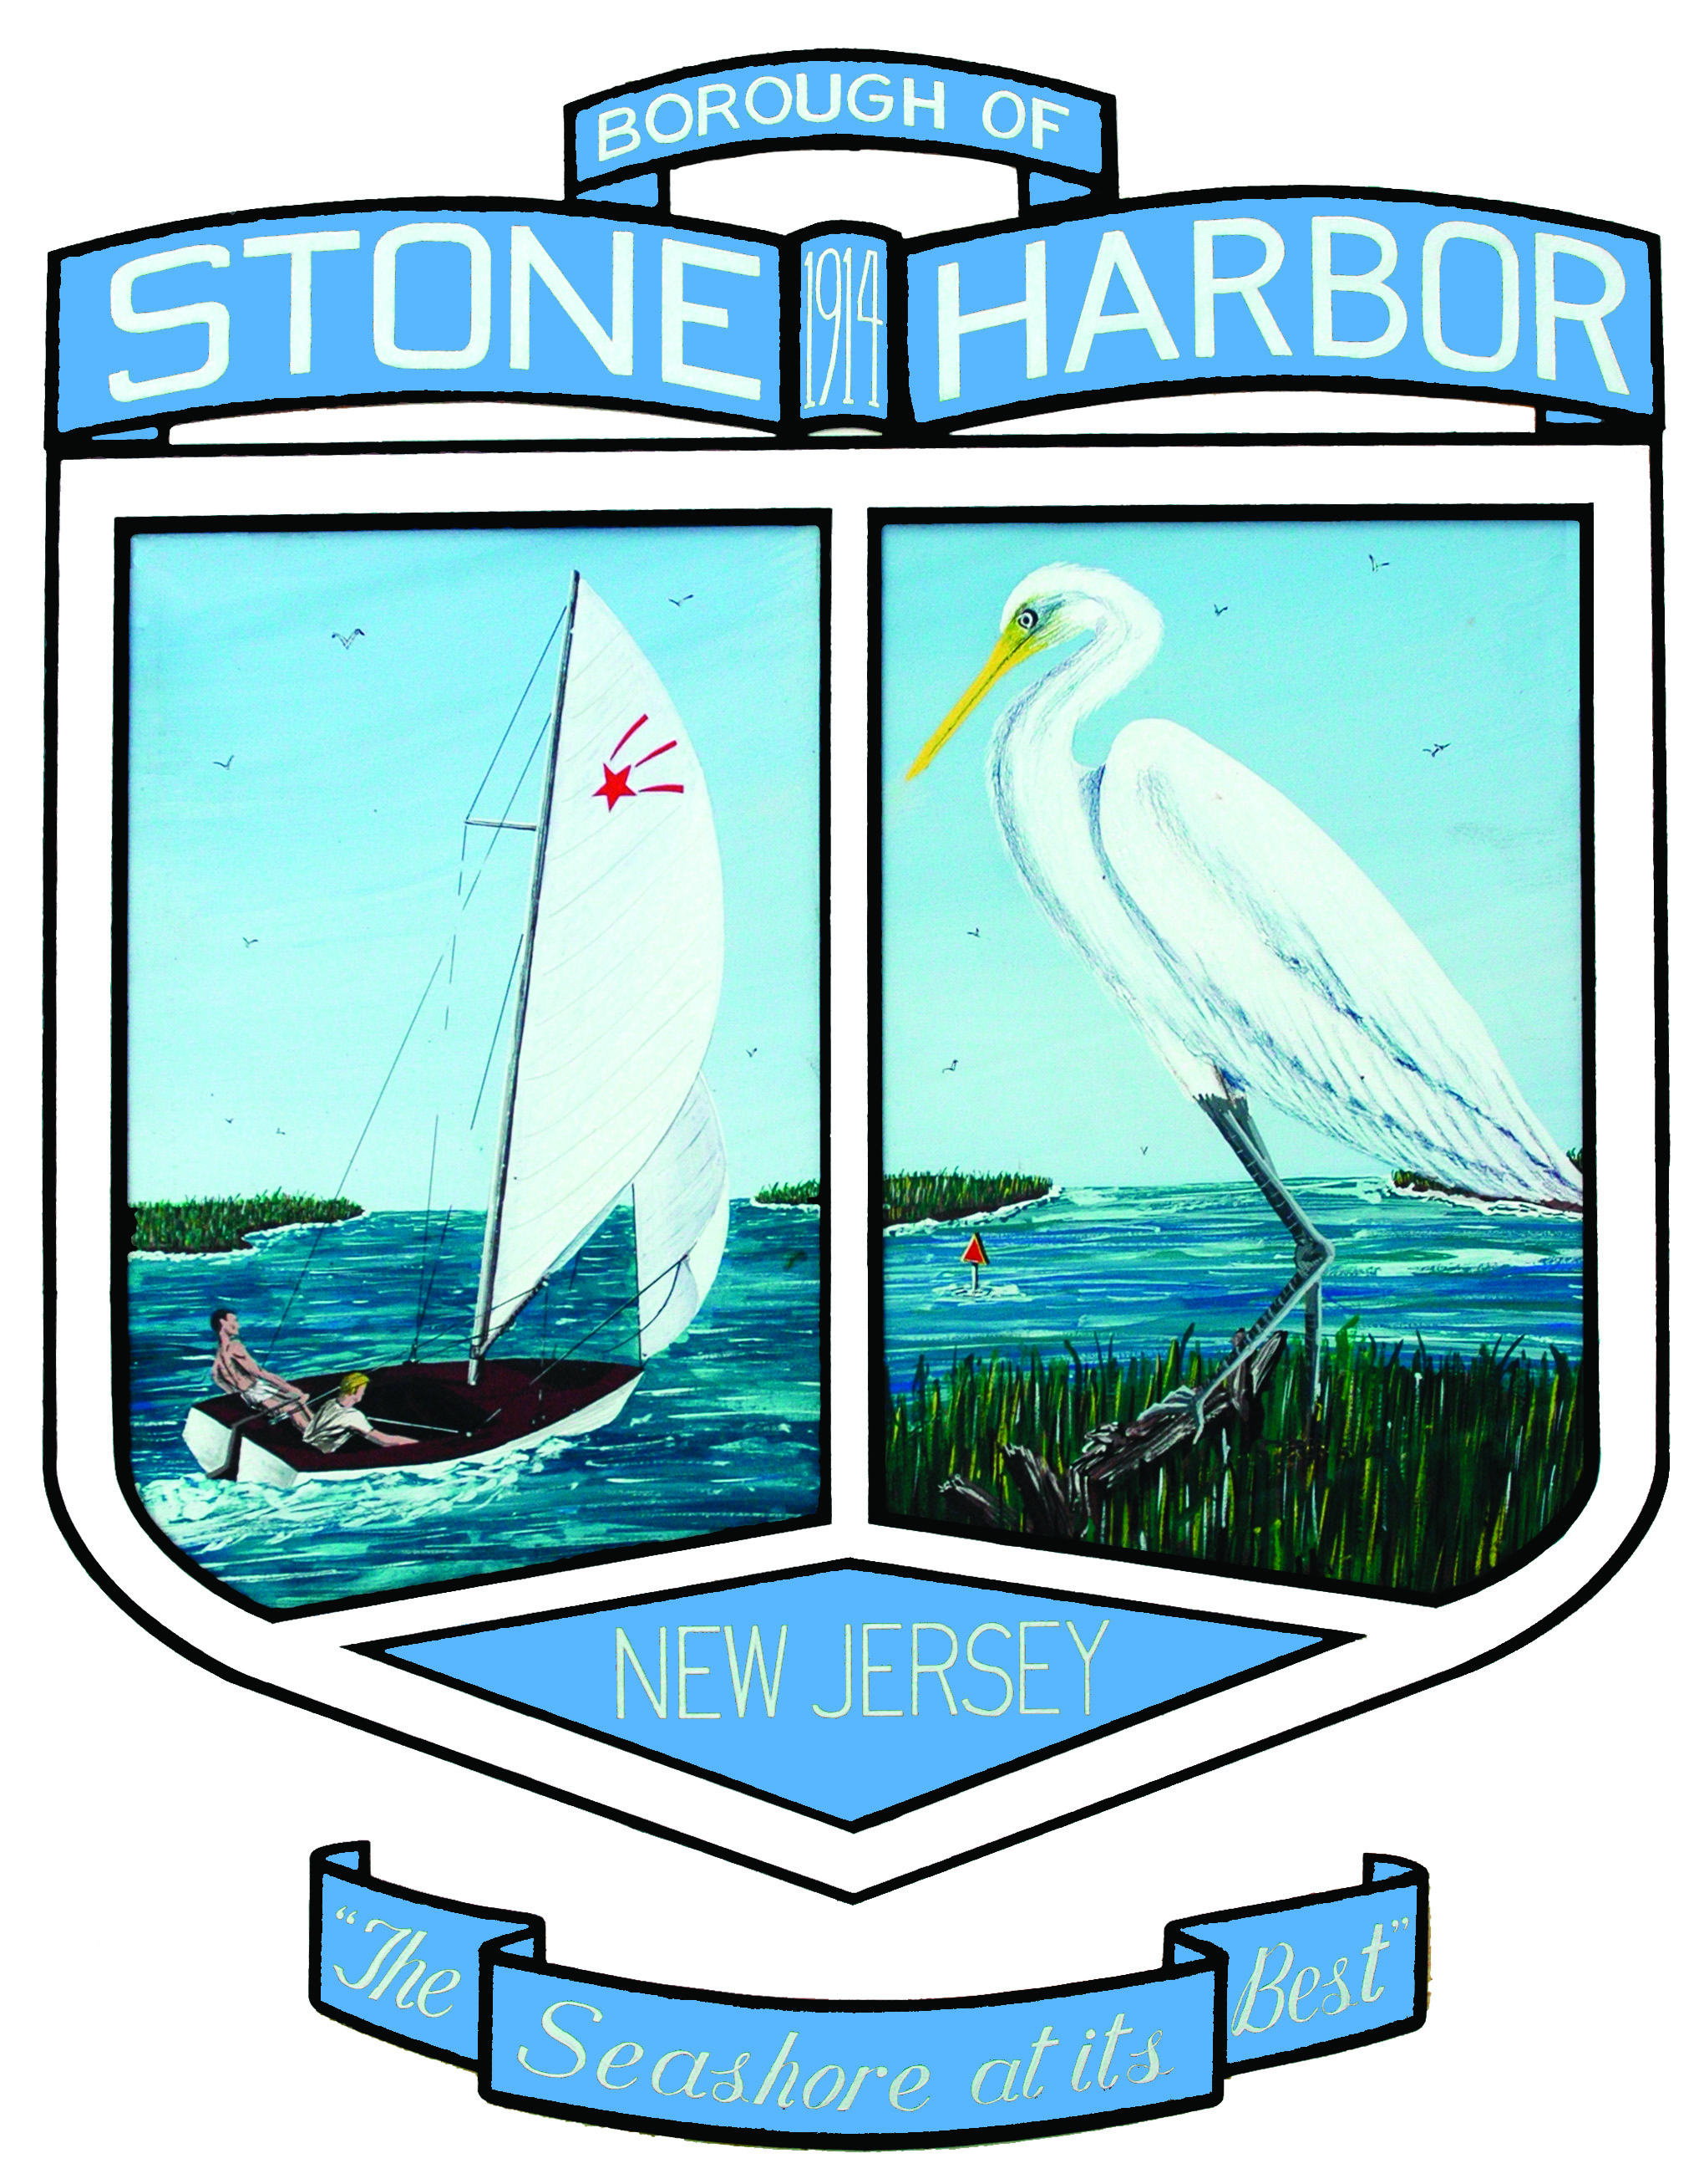

STONE HARBOR DREDGING UPDATE 3/3/2016
Following approval from both the United States Army Corp of Engineers and the New Jersey Department of Environmental Protection, the Stone Harbor City Council approved an extension to the Stone Harbor Maintenance Dredging project to allow sand that is separated from the dredged material to be placed on the beach. Currently, all dredged materials are trucked to the mainland for disposal. Returning the sand to beaches is a big step in conserving our natural resources.
The extension will permit dredging activities and demobilization until April 30th and May 14th, respectively. After completing the Shelter Haven Basin, dredging will proceed at the Access Channel and Stone Harbor Hole. Both areas have a high sand content. The sand will be separated from the fine grained silt and clays at the Stone Harbor Marina parking lot between 80th and 81st streets. The sand will be tested daily and trucked to the beaches. Trucks will travel from the marina to the 95th street parking lot to be weighed and then cross over the dune to the beach. Sand will be placed and graded from 83rd to 122nd streets between the eroded dune toe and mean high water line. This sand will provide additional protection until the federal beachfill project restores the beach later this year.
Please be advised that the construction activities will result in temporary closures to public spaces and increased truck traffic through town. The contractor is scheduled to work Monday through Saturday from approximately 6 AM to 6 PM. Stone Harbor Marina parking lot will be closed to the public through May 14th. Portions of the 95th street parking lot will be closed to the public through May 14th. Sections of the beach will be closed to the public during beachfill activities.

