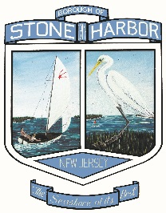

July 31, 2018

TO: Jill Gougher, Borough Administrator
FROM: Kim Stevenson: Administrative Assistant
RE: Flood Information Mailing

Please accept this memo as certification that the Cape May County Preliminary Work Map (Panel 0242) which contains General Preparedness and Flood information for storms and other events along with links to websites that can provide homeowners within the Borough of Stone Harbor interactive mapping, flood safety and preparedness and contact information was mailed to all property owners along with the yearly mailing of the Borough’s Tax Bills.
This mailing was completed on July 26th, 2018.
In addition, this information was posted on the Borough of Stone Harbor website under News & Announcements as well as included on our Flood Information page which provides information on Flood Preparedness, Mitigation and Insurance and all documentation pertaining to the CRS Certification.

